UNRWA Food Distribution
Rafah
8 December
© Fadi Thabet

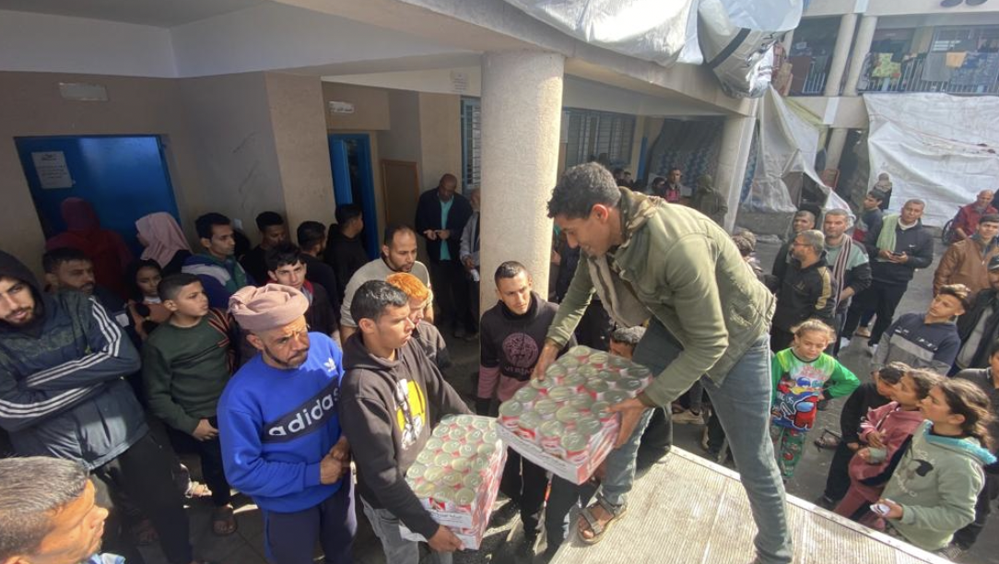

On 8 January 2024, UNRWA continues to distribute food assistance to the displaced population in the Rafah area, amidst large-scale displacement operations from central Gaza to the south. Photos by Fadi Thabet

