KYTC
23 January 2024
Photos from Hussein Owda

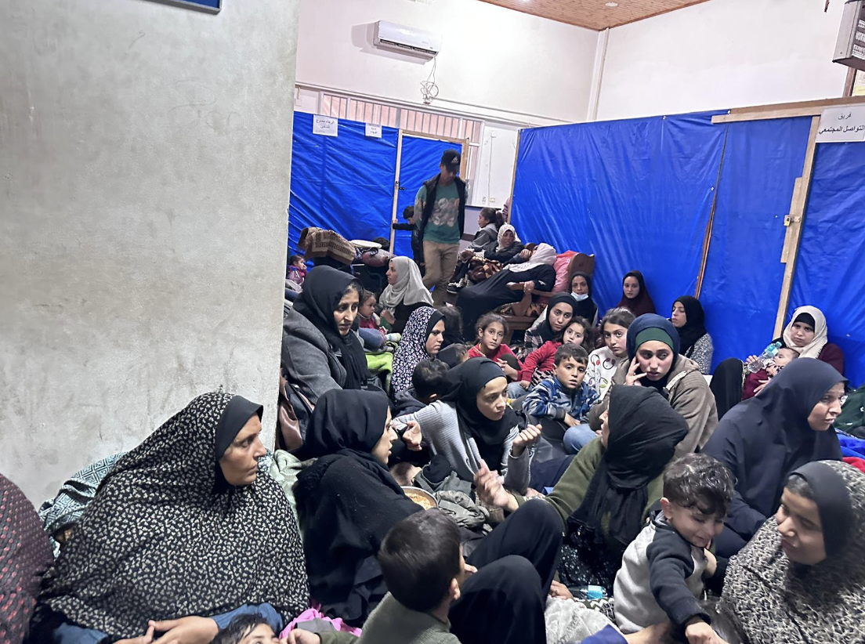

Thousands of internally displaced people (IDPs) at the UNRWA Khan Younis Training Centre (KYTC) in southern Gaza seek refuge in the corridors of buildings due to ongoing shelling and gunfire from outside and above the shelter. Numerous injuries are observed, and additional casualties have arrived from neighboring areas and tents surrounding the shelter.

